Hybrid embedded system Results

MultiRoomHeating4x2_AsyncJitter_Faults.
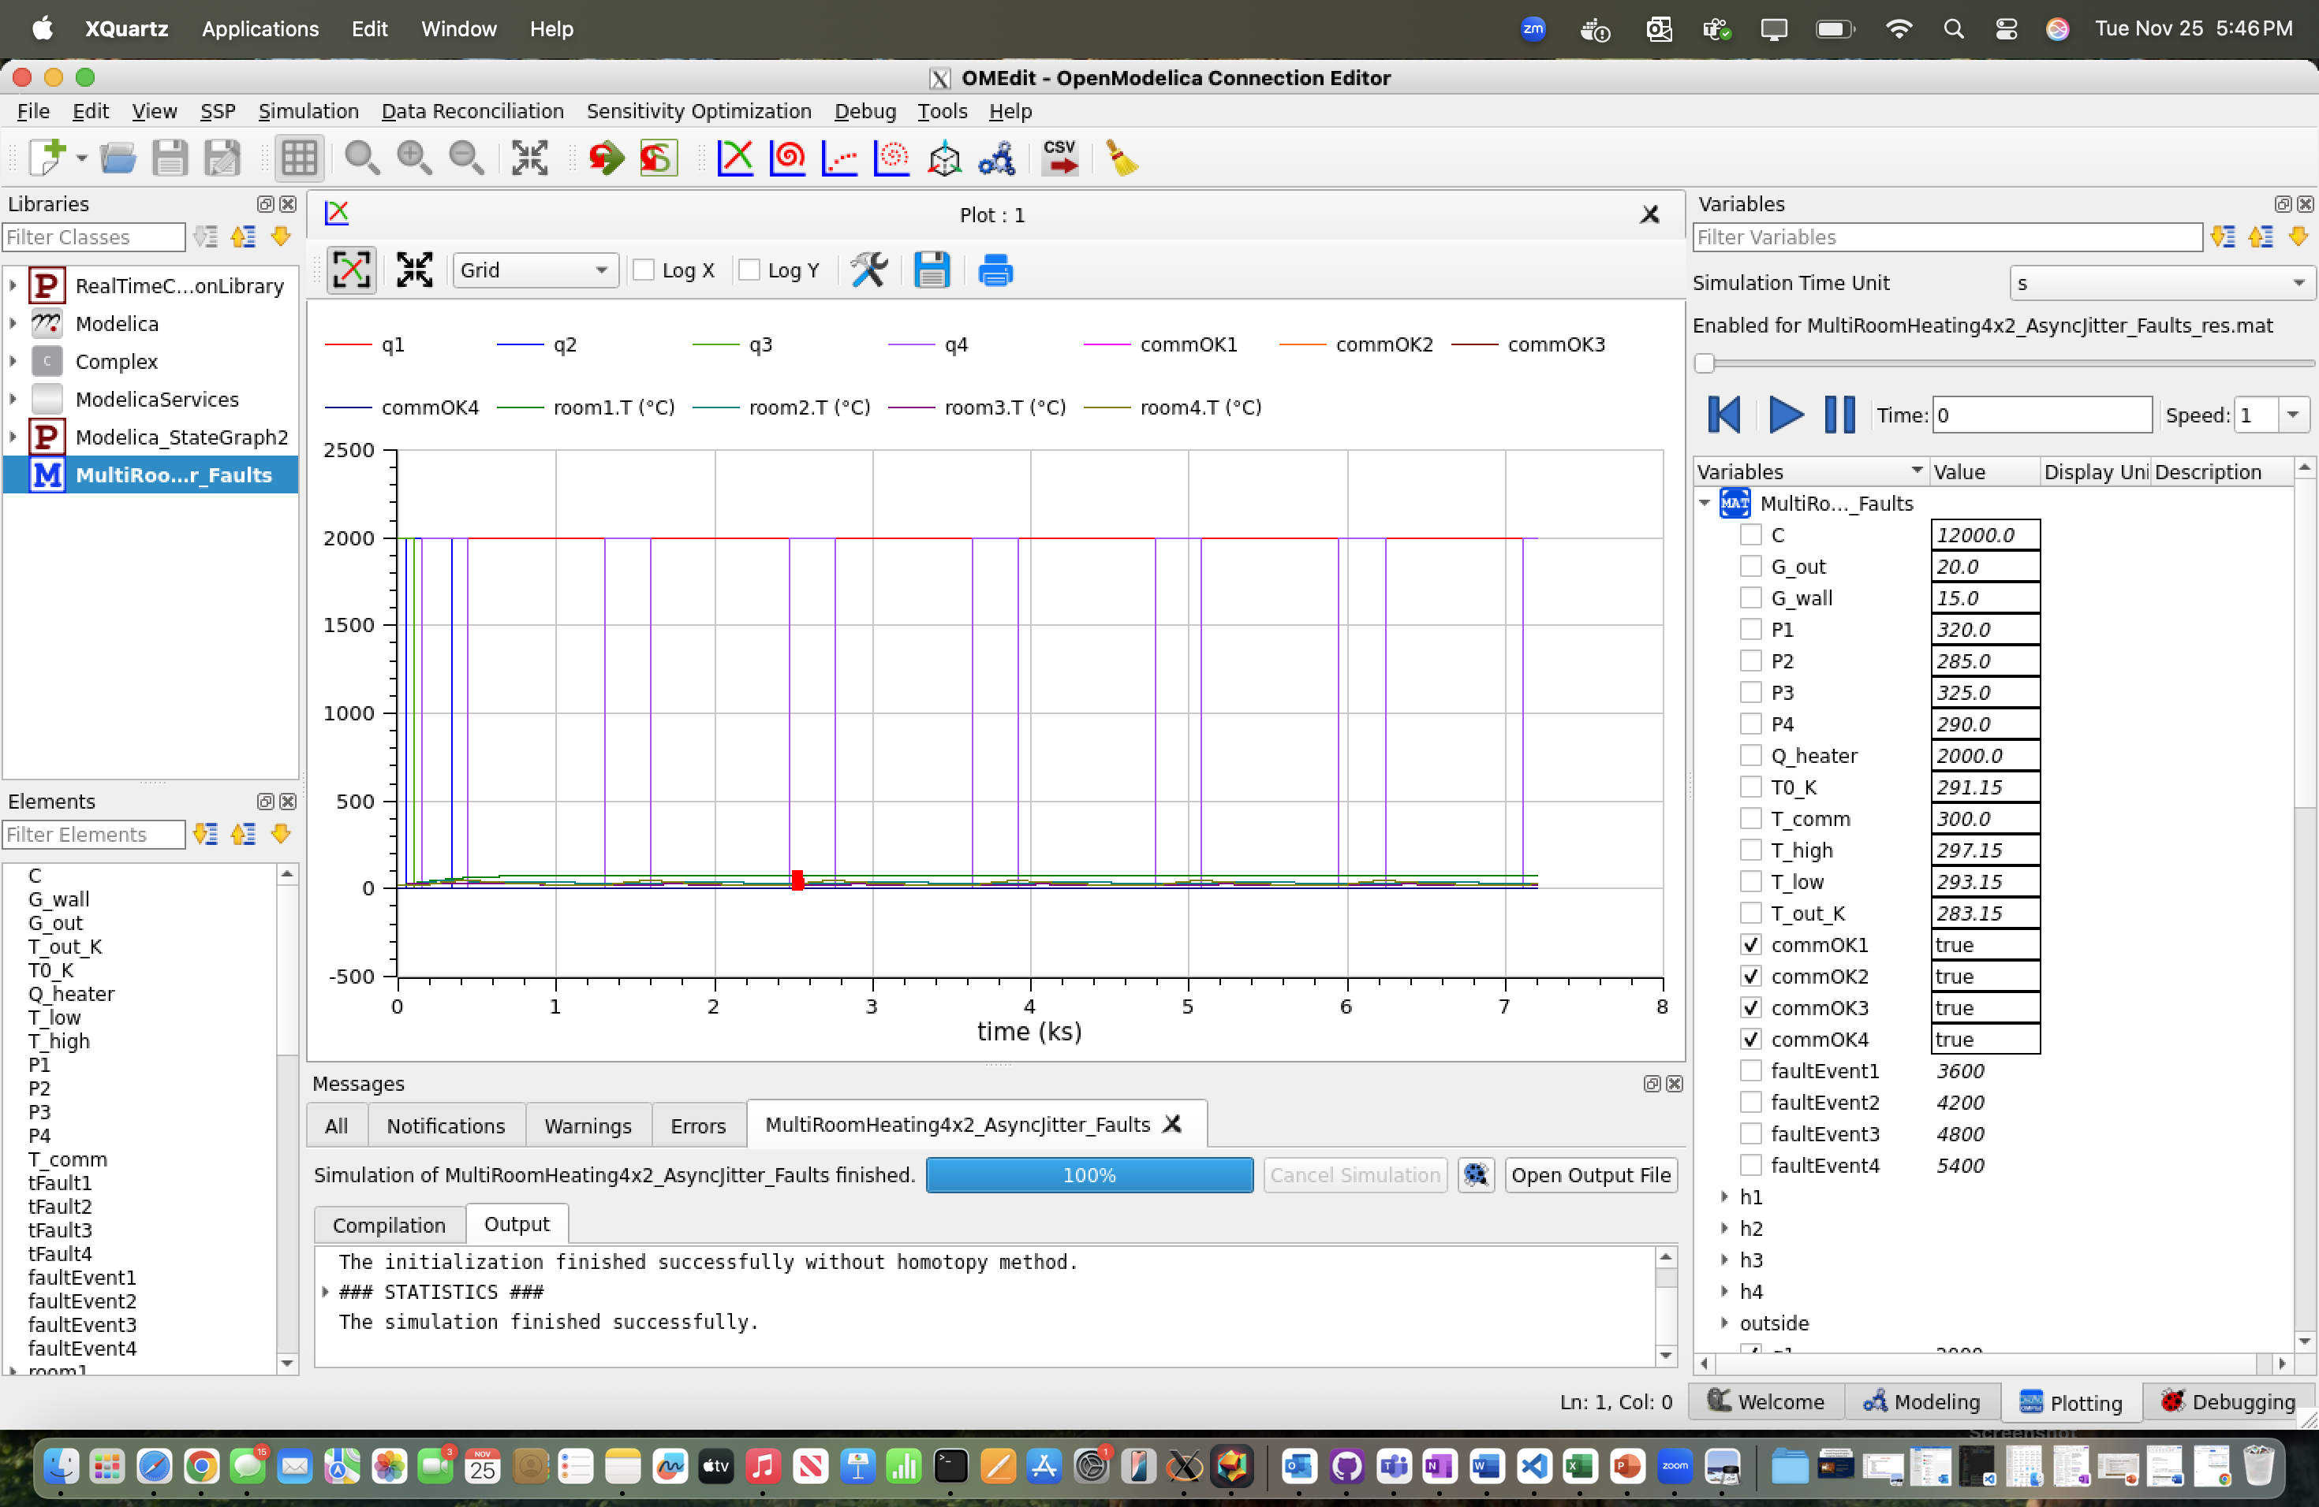

Asynchronous energy
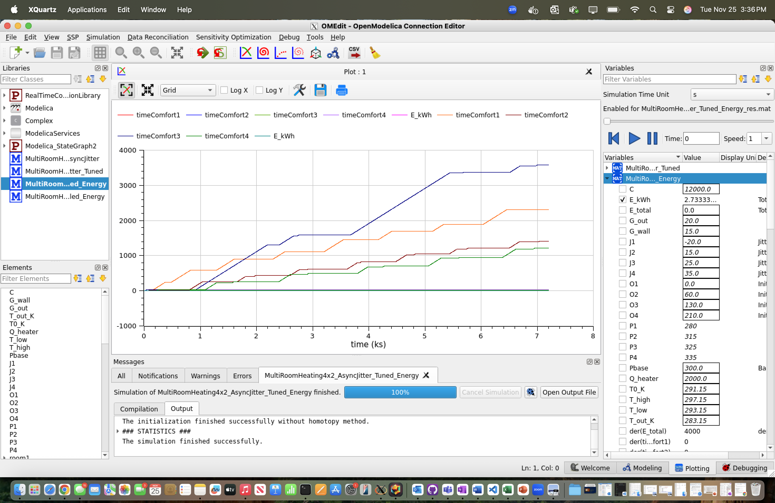
Synchronous energy
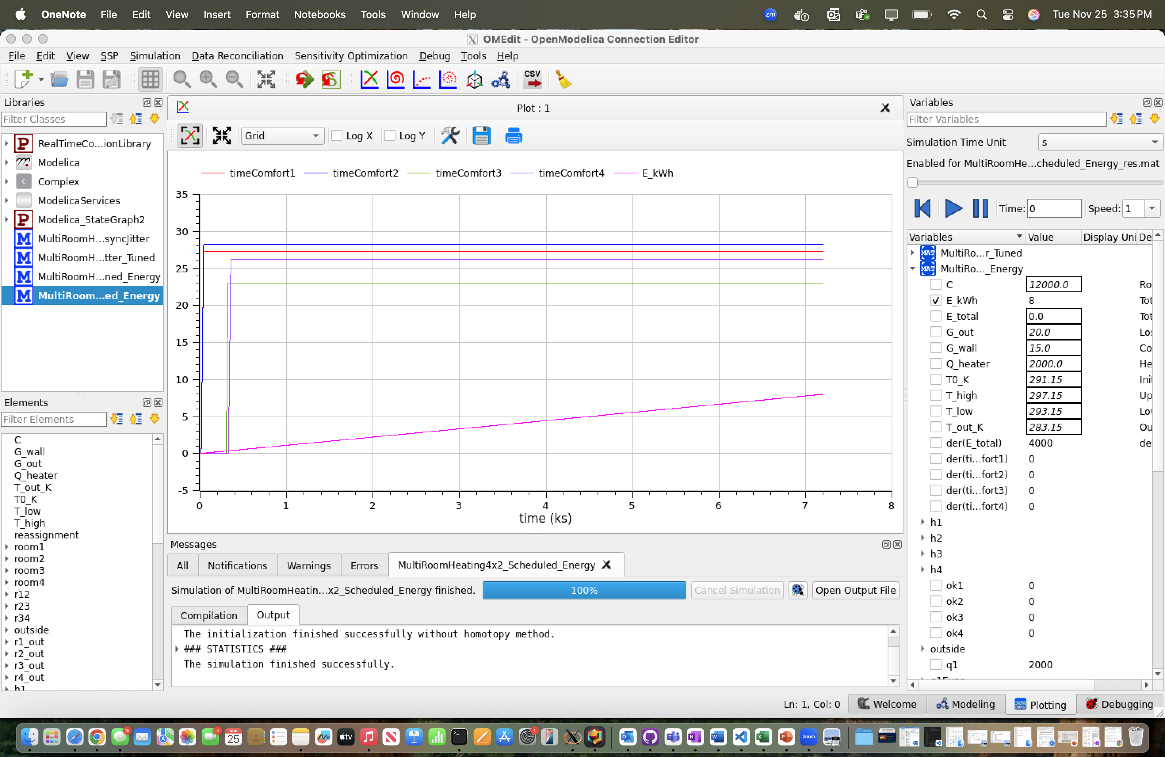

Refine jitter timing for smoother independence. MultiRoomHeating4x2_AsyncJitter_Tuned.mo
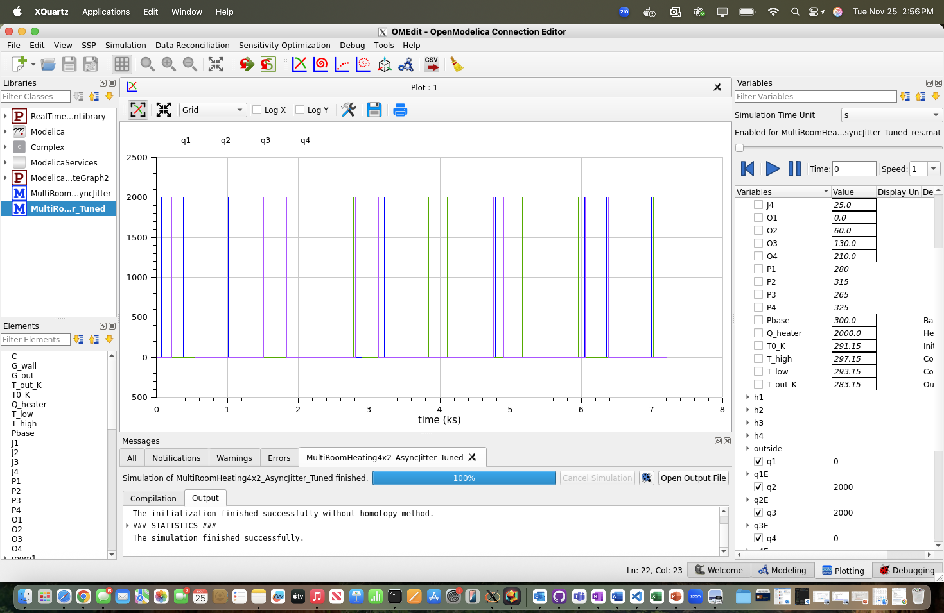

Asynchronous
